An Isomorphism Based Algorithm to Solve Complex Problems in Communication Networks
¹Alberto Arteta, Danush Wijekularathna²,Nuria Gomez, ³Luis F. de Mingo⁴
^{1,2}Computer Science and Math Department Troy University University Avenue,Troy Alabama 36081, United States{aarteta, dwijekularathn@troy.edu}
^{3,4}Dpto. Organización y Estructura de la Información, Technical University of Madrid UPM, Crtra Valencia km 7,28031, Madrid, Spain {ngomez, lfmingo@eui.upm.es}

Abstract
During years proper memory utilization has been the differential factor for algorithms that try to solve complex problems in optimal time. Computational complexity is currently measured in time and space. The way that algorithms are built can make a huge difference when initiating a communication protocol. Memory engineering based algorithms reveal themselves as essential when fast results are needed and offer unlimited options to improve whatever bioinspired algorithm that based its performance in terms of time and space. This work focuses on creating a mathematical generic strategy by building structures through the use of an isomorphism that optimize the memory utilization and the resolution time of bioinspired models when dealing with high computational problems when reducing communication time between devices. Therefore offers a great help when solving complex and known issues in communication protocols.

Keywords: - Bioinspired models,; General Optimization; Complex problems resolution

- Introduction
The concept of transition p-system was first introduced in a 1998 by Gheorghe Paun[1][2], whose last name is the origin of the letter P in 'P Systems'. Variations on the P system model created what we call 'membrane computing. [3][4]'This model was inspired by biology, however P systems were used as a computational model, instead of a biological model. Nowadays there are some attempts of creating new biological models through the use of p-systems.

In [5] there are some keywords related to membrane computing such as parallelism, distributed applications, algorithms. Paun avoids stating that there are implementations of p-systems. This happens because the model he proposes has an inherent parallelism and non determinism. Those characteristics cannot be implemented in a conventional computer. [1].
Regarding simulators, [2] remarks: simulations on conventional computers can be useful too: In fact all these programs were used on biological applications and they can also play an important role for didactic purposes and to establish new researching areas.
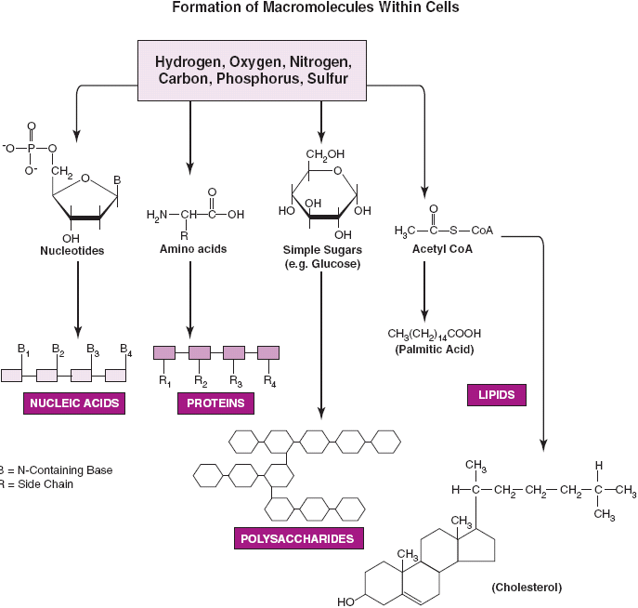
The living cells we see that they process food and nutrients in a very characteristic way. Living cells get atoms or molecules and then react by producing other atoms and molecules.
Fig. 1.Food processing cycle in living cells.

- This process has been studied and it has also been tried to implement into computers. Living cells act and process nutrients according to certain rules that take place in a parallel and in a non deterministic manner[7]. This model has been copied by many researchers to establish new machines that process information in the same way. In 1998 George Paun studied the described biological model and then was able to create what we call nowadays ‘Membrane computing’. This was created mainly inspired on the processes that take place inside of the living cells. After analysing such processes, it is noticeable that they have properties that can be used into a computational model. This model was a revolution because it opened new researching areas for solving NP-complete problems.
- Foundations and organizations were aware of this new revolutionary way of computing and encouraged the research on that direction. Examples of these are EMCC (European Molecular Computing Consortium) and The Consortium for Biomolecular Computing.
- In 2004 the official p-system web http://psystems.disco.unimib.it was created; since then, it has been supported by the EMCC
- In February 2003 membrane computing was defined as “the most revolutionary way of computing within ICT”. This was said by the Institute of Scientific Information.
- The transition P-systems have been suffered a transformation themselves. This transformation comes from the desire of collecting more biological properties. Moreover the use of automats has been added to improve the performance of p-systems. One of the main goals for the p-systems to achieve is the resolution of Np completes problems in polynomial time.
- Natural computing group in Madrid is currently working on implementing p-systems in specialized hardware. The parallelism degree achieved is high and the temporary results obtained are promising. Also, the idea of reducing to practice the p-systems is more realistic.
- Algorithms for applying evolution rules are getting improved too[7][8]. A new algorithm that obtains optimal results when simulating the rules application phase, is about to be published. This algorithm use combinatorial laws and statistics.
- Np complete problems have been solved in polynomial time and sometimes even in linear. We are working closer with biological areas and now there is a membrane computing application in biology. It is believed that membrane computing can be a reliable framework to model living cells processing.[9][10]
- Moreover, this group has avoided approaching p-systems as an isolated technology has worked on scenarios in where the p-systems can work together with multiagent systems orautonomous robots to find optimal solutions to known problems.[11],[12],[13]

2. Definitions
Pattern

Set of Patterns is a Set of patterns and it is defined as the set:
Set of set of patterns
Observation
Given a region R and alphabet of objects U, and R (U, T) set of evolution rules over U and targets in T represented as follows:

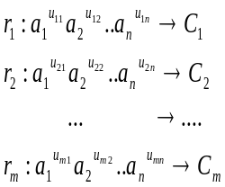

all the possible extinguished multisets and it is obtained by expanding the formula included in the definition of extinguished multiset:
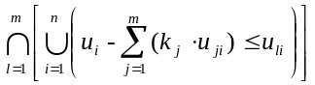 (2)
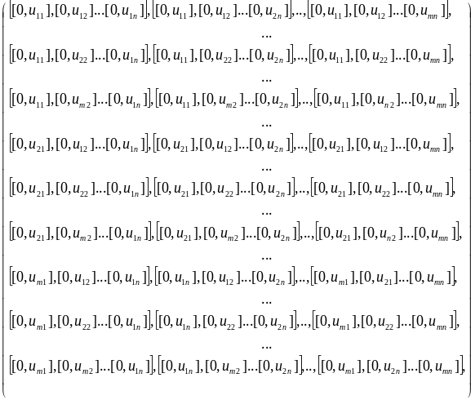

Linear Multisets isomorphism 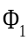
Building, as a part of the physical evolution rule isomorphism is created as a function which has an m-dimensional set of natural numbers as input and an n-dimensional set of natural numbers as output, where m is the number of evolution rules and n is the number of symbols included in a given multiset of objects.

Definition: Linear Multisets function
Let U=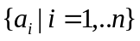be a set of objects. Let T beset of targets. Let 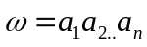 be a multiset of objects and let  be the multiplicity of . Let R (U, T) be a multiset of evolution rules with objects in U and targets in T. Let m be the number of evolution rules within R (U, T). Let be the number of times that the rule 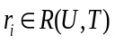 is applied. Then is defined as:

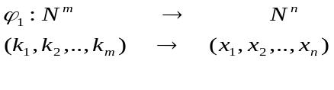
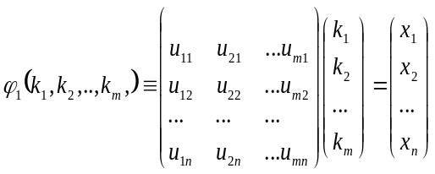

Once the function is created, the isomorphism 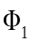 is defined as follows:

Definition: Linear Multisets isomorphism
Let be the multiset linear function related to a given evolution rules set 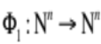
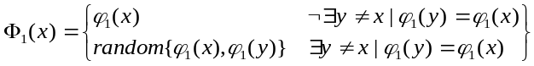 (4)

Definition:
Physical evolution rules linear Isomorphism is then defined as follows:
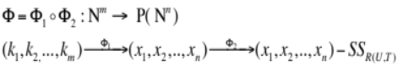 (5)
Based on the previous definitions, the following one is established and created to take full advantage of the virtual memory.

Definiion: Virtual linear Multisets function

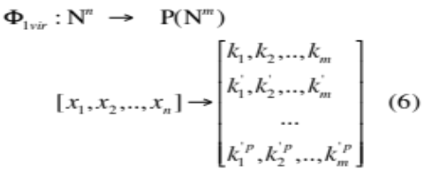
Given an input 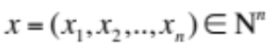it returns the set of numbers

Definition: Virtual linear Pattern function

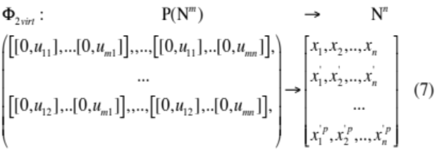

Given a set of set of patterns as the input it returns a set of numbers . The elements of this resulting set are all the combinations of all the possible , where, .
of a set of patterns contained in the matrix of set of patterns. .Now it is possible to build the physical and virtual linear structures from the multisets isomorphism.

3. Isomorphism Based Structure
The structure is created as follows.

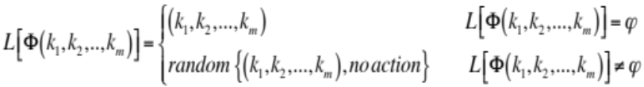

When L (i, j) already has a value, then, a random election must be done. This election can be either overwriting the old value with the new one, or to leave the old value (No action).This linear structure has to comply with having all possible numbers, up to a combination of benchmarks, reasonably high. Each symbol 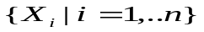 will have a benchmark. The combination of all the benchmarks will define the number of entries that the linear structure has. Each entry stores the values 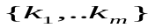. These values indicate the number of times that an evolution rule should be applied to an initial multiset in order to obtain an extinguished multiset.

The linear structure must guarantee that it contains all the entries corresponding to the combination number of all benchmarks associated to the symbols, i.e. it cannot have nonfunctioning entries. That could damage response timing and it would increase the computational complexity in terms of time. It's necessary to prove that this structure has not null values.
Let be a linear structure built from the evolution rules isomorphism and a certain V multiset of objects and R (U, T) multiset of evolution rules.
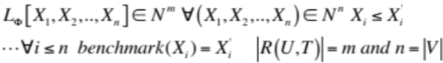

Proof
Let 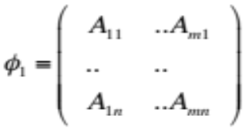 be the function associated to R (U, T)

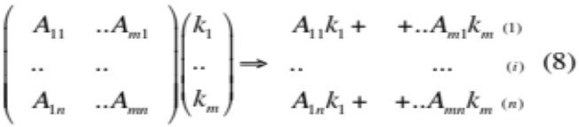
A resulting set of n-sums is obtained. Let = {min 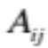 of the sums (i)} .Moreover, let 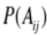be the Matrix of set of patterns resulting from R (U, T). . Proof is trivial
Thus, .
Observation:
This proves that when following this method, any natural number from 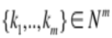 can be generated. Thus, the structure does not have null values from any entry. As the process is an isomorphism, any natural number between 0 and a given benchmark will be uniquely related to a combination of where m is the number of evolution rules included in R (U, T). Moreover the calculation of extinguished multisets will be immediate.

When are found, applying the evolution rule 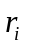 a number of 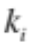times to the initial multiset, will calculate them.
Given V= {be a multiset of symbols and given R (U, T), a multiset of evolution rules. Given the set {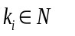the number of times that the evolution rule is applied over the initial multiset} the following evolution rules function is defined:
(9)

Consistency theorem
The linear structure must guarantee that it contains all the entries corresponding to the combination number of all the benchmarks associated to the symbols, i.e. it cannot have nonfunctioning entries. That could damage response timing and it would increase the computational complexity in terms of time. It's necessary to prove that this structure has not null values.
Let be a linear structure built from the evolution rules isomorphism and a certain V multiset of objects and R (U, T) multiset of evolution rules.
Proof:
Let
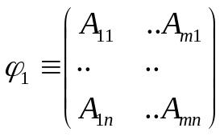 be the function associated to R (U, T)
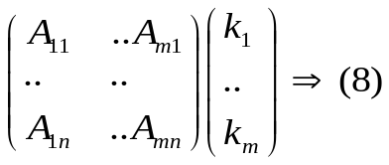
.
A resulting set of n-sums is obtained. Let = {min of the sums (i)} .Moreover, let be the Matrix of set of patterns resulting from R (U, T). . Proof is trivial
Thus, .
Remark:
This proves that when following this method, any natural number from can be generated. Thus, the structure does not have null values from any entry. As the process is an isomorphism, any natural number between 0 and a given benchmark will be uniquely related to a combination of where m is the number of evolution rules included in R (U, T). Moreover the calculation of extinguished multisets will be immediate. When are found, applying the evolution rule a number of times to the initial multiset, will calculate them.

4. Virtual Structure
The structure is created as follows.

When L (i, j) already has a value, then, a random election must be done. This election can be either overwriting the old value with the new one, or to leave the old value (No action).This linear structure has to comply with having all possible numbers, up to a combination of benchmarks, reasonably high. Each symbol will have a benchmark. The combination of all the benchmarks will define the number of entries that the linear structure has. Each entry stores the values . These values indicate the number of times that an evolution rule should be applied to an initial multiset in order to obtain an extinguished multiset.

The linear structure must guarantee that it contains all the entries corresponding to the combination number of all benchmarks associated to the symbols, i.e. it cannot have nonfunctioning entries. That could damage response timing and it would increase the computational complexity in terms of time. It's necessary to prove that this structure has not null values.
Let be a linear structure built from the evolution rules isomorphism and a certain V multiset of objects and R (U, T) multiset of evolution rules.

Proof
Let be the function associated to R (U, T)

A resulting set of n-sums is obtained. Let = {min of the sums (i)} .Moreover, let be the Matrix of set of patterns resulting from R (U, T). . Proof is trivial
Thus, .
Observation:
This proves that when following this method, any natural number from can be generated. Thus, the structure does not have null values from any entry. As the process is an isomorphism, any natural number between 0 and a given benchmark will be uniquely related to a combination of where m is the number of evolution rules included in R (U, T). Moreover the calculation of extinguished multisets will be immediate.

When are found, applying the evolution rule a number of times to the initial multiset, will calculate them.
Given V= {be a multiset of symbols and given R (U, T), a multiset of evolution rules. Given the set {the number of times that the evolution rule is applied over the initial multiset} the following evolution rules function is defined:
(9)

Consistency theorem
The linear structure must guarantee that it contains all the entries corresponding to the combination number of all the benchmarks associated to the symbols, i.e. it cannot have nonfunctioning entries. That could damage response timing and it would increase the computational complexity in terms of time. It's necessary to prove that this structure has not null values.
Let be a linear structure built from the evolution rules isomorphism and a certain V multiset of objects and R (U, T) multiset of evolution rules.
Proof:
Let
be the function associated to R (U, T)
.
A resulting set of n-sums is obtained. Let = {min of the sums (i)} .Moreover, let be the Matrix of set of patterns resulting from R (U, T). . Proof is trivial
Thus, .
Remark:
This proves that when following this method, any natural number from can be generated. Thus, the structure does not have null values from any entry. As the process is an isomorphism, any natural number between 0 and a given benchmark will be uniquely related to a combination of where m is the number of evolution rules included in R (U, T). Moreover the calculation of extinguished multisets will be immediate. When are found, applying the evolution rule a number of times to the initial multiset, will calculate them.

- Example
This example describes the steps to create both structures. In the first part isomorphism is defined, it will then create the structure and place it in the RAM.
In the second part, another function is built and then allocated within the virtual memory. The example considers a situation where the number of symbols is less than the number of evolution rules, which is the most interesting case for this analysis.

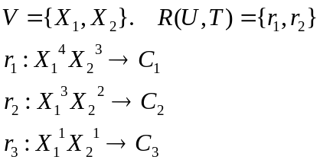
From this, the set of patterns obtained is as follows:
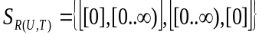
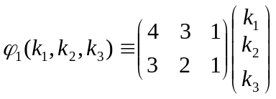
Let's set 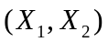benchmarks as (10, 12)
Let 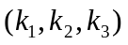 be selected randomly. For example:
= (0, 0, 1)
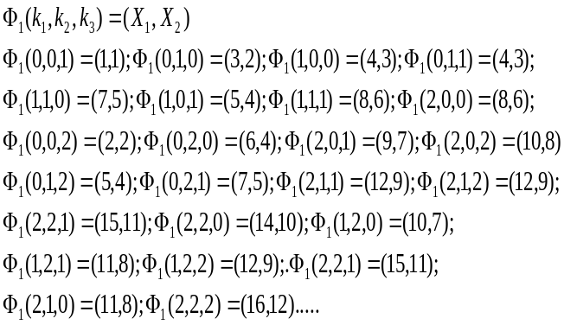
Once is completed, the next step is building the function 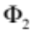
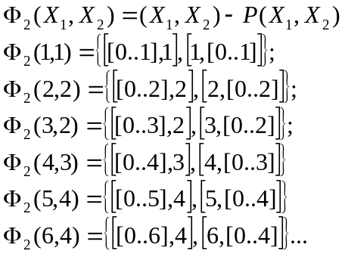
Now there is enough information to build the physical linear structure in this example. A way to build the structure could be:
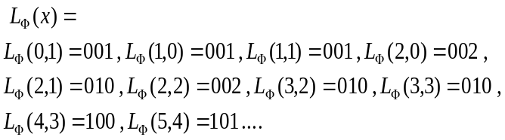
Once this structure is created, it will be allocated in the RAM. At this moment it is possible to build the virtual linear structure. The process is similar to the one above. The main difference will be that in each cell a concatenation of values will be stored instead of just one value.
The structure is built as follows:
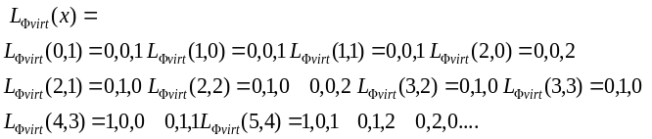

- Technique Analysis and Algorithm
Building the structures guarantees, that any input value 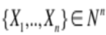 has a direct relation with . This implies that the structure can be built after certain evolution rules are given. In this way, any algorithm that intends to calculate an extinguished multiset from an initial multiset of objects can generate the linear structure during the compilation time.
During the compiling stage of an algorithm, two new structures are created. When the multiplicities of the initial multisets are provided as input values of a given algorithm, this algorithm will search the entry 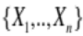 of the physical structure. Thus the algorithm returns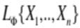. After the value is returned, a new value is generated by searching the entry 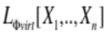and then selecting randomly one of the possible combinations of 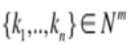 stored in that entry. Once it is selected, this value would overwrite the value . The way that the structure has been created, assures that for each input values, different outputs might be generated. Thus, the use of the linear structure preserves the non-determinism, which a characteristic of the Paun biological model.
In both structures, the number of cells that requires is:
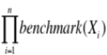
where n is the number of symbols of the current multiset.
The combination of the number of symbols and the selected benchmarks of each symbol will determine the number of cells that the linear structure must have. Thus, the combination of these two factors has a major influence in the amount of memory used by .
Within the last years, algorithms have been developed to calculate extinguished multisets. They have achieved a computational complexity equal to 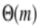 where m is the number of evolution rules involved.
When the number of evolution rules is high, the execution time can take too long. On the contrary, the best scenario for this technique is when the combination between number of symbols and their benchmarks is low, regardless the number of evolution rules and the maximum applicability benchmark of any evolution rule.
For instance, let us consider a hypothetical scenario where the multiset of symbols 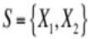 , and the number of evolution rules is 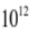. Let us also consider that the maximum value that an evolution rule can be applied is 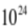.
Under these conditions, an algorithm as the fast linear algorithm [16] is inefficient as its complexity is O (m) where m is the number of evolution rules. On the contrary, an algorithm that uses this technique can find extinguished multisets with a constant complexity order. When using this technique, it is necessary to reserve 124 bits for each structure's cell as per: 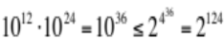.
This means 15 bytes per cell .Let us set a benchmark of 30000 for each symbol of the multiset. Considering that there are two symbols within our current Multiset: , then: 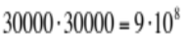 number of cells of . Thus, the amount of memory needed to create is .
Thus, when having 13.5 Gb any algorithm using this technique can find extinguished multisite with complexity order O(1) as long as Input values for 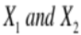 multiplicities are <30000. This will occur regardless the number of evolution rules.
The amount of memory needed to create the virtual structure increases as every cell can store more than one set of numbers, i.e. 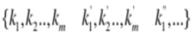 , Let us assume that the maximum number of combinations 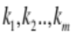 stored in each entry is 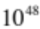. This means 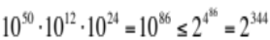. This means 43 bytes per cell.
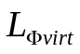=
Once this is done, both structures are built. The physical structure relates the number of times that each evolution rule should be applied to the multiplicity input values of the initial multiset. This occurs as long as these values are always either less than or equal to their benchmark.
An algorithm, as the one based on the maximum applicability benchmark, could create the structures during compilation stage. If the number of evolution rules is high, it would be worth considering creating the structures. This finds the corresponding values to the number of times that each rule should be applied in order to obtain an extinguished multiset. This happens as long as the input values of the object’s multiplicities are lower than the previously fixed benchmarks.
Following is the code that returns the multisets as outputs
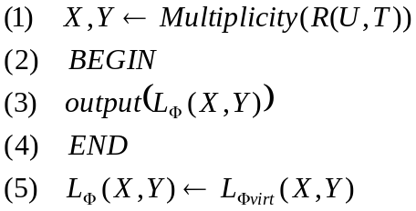

The algorithm search in the physical structure the position(X, Y) which are the input values corresponding to the multiplicities of the initial multiset. When the value is returned, the algorithm finishes and a new value coming from the virtual structure overwrite the value stored in the position (X, Y), keeping the non deterministic nature of the system.

Conclusions
Although it is clear that proper memory utilization is a great help to speed up the information processing, it is still necessary to build the right structures to optimize the performance; and that is not always easy. This paper contributes with a general technique that consists of building an isomorphism based structure that improves the performance of traditional algorithms when dealing with complex problems. The isomorphism matches the initial data sets multiplicities with the number of times that each rule should be applied in order to obtain solutions in optimal time; In that way, this method clearly reduces the execution times of the algorithms when finding maximal or extinguished multi data sets.
The nature of the isomorphism ensures that the main bioinspired system features are preserved and the overall system’s functionality is not modified, the only difference between the first model and the second one is the performance. Although the idea of using memory resources to increase performance when solving complex problems is not new [14], defining the right structure based on isomorphism can offer a promising way to generalize and to create a standard methods for optimizing the memory resources of traditional algorithms. Improving the design and the implementation of new isomorphisms reveal themselves as keys factors in the strategy to deal with complex problems by utilizing memory engineering.

- References
- Nidhal kamel taha el-omari “Scanned document image segmentation using back-propagation artificial neural network based technique” North Atlantic University Union (NAUN) International journal of computers and communications issue 3, volume 6, 2012

- New Approach to Optimize Membrane Systems , Alberto Arteta,, Luis Fernando Mingo, Nuria Gomez, Journal of Bioinformatics Jan 2014, Vol. 1 Iss. 1, PP. 1-6

- Enhancing Parallel Recursive Brute Force Algorithm for Motif Finding , 103 Marwa Radad recent advances in computer science proceedings of the 6th wseas world congress: applied computing conference (acc '13) 103-11 , 2013
- Dimitar ivanov, univis – “A 3d software system visualization using natural metaphors” pages: 107-119 International Journal of computers Issn:1998-4308 volume 8, 2014 North Atlantic University Union (NAUN), 2014
- Gh. Păun, “Computing with Membranes”, Journal of Computer and System Sciences, 61(2000), and Turku Center of Computer Science-TUCS Report nº 208, 1998.
- Gh. Păun, “Membrane computing. Basic ideas results, applications”, Pre-Proceedings of First International Workshop on Theory and Application of P Systems, Timisoara (Romania), pp. 1-8, September , 2005.
- Kenneth Price, Rainer M. Storn, and Jouni A. Lampinen. Differential Evolution: A Practical Approach to Global Optimization (Natural Computing Series). Springer- Verlag New York, Inc., 2005.ISBN 3540209506..
- Lingian Pan, Carlos Martin-Vide ''Solving multidimensional 0-1 knapsack problem by P systems with input and active membranes'', Journal of Parallel and Distributed Computing Volume 65 Issue 12 (December 2005)
- Lin, Shen, Kernigham BW An Effective Heuristic Algorithm for the Traveling-Salesman Problem". Operations Research 21 (2): 498–516. doi:10.1287/opre.21.2.498. Volume 21, Issue 2, March- April 1973,
- A. Arteta, L.Fernandez, J.Gil “Algorithm for Application of Evolution Rules based on linear diophantine equations” Synasc 2008.Timisoara Romania September 2008
- Arroyo, A. Arteta,, A. Goñi. Calculating maximal multisets using RAM as support, Artificial life and Robotics 2010, Beppu Japan
- Alberto Arteta, Nuria Gomez Luis Fernando Mingo. ,Solving complex problems with a bioinspired model. Engineering Applications of Artificial Intelligence,Volume 24, Issue 6, September 2011, Pages 919–927
- Alberto Arteta ,, Angel Castellanos, Ana Martinez: Membrane computing: non deterministic technique to calculate extinguished multisets of objects. International Journal “ Information Technologie s and Knowledge”, Vol. 4, Number 1, 2010
- Chiang, Jui-Hao. Optimization Techniques for Memory Virtualization-based Resource Management Publisher: The Graduate School, Stony Brook University: Stony Brook, NY. Date: 1-Dec-12
- Ganon, Jalby Strategies for cache and local memory management by global program transformation Journal of Parallel and Distributed Computing, Volume 5, Issue 5, October 1988, Pages 587–616

Acknowledgment
This work has been partially supported by the Spanish Research Projects:
- PARTIALLY SUPPORTED BY TEC2010-21303-C04-02 AND CS Department of Troy University

